Experiment 12
Implement Iris Flower Classification using KNN

Aim
To implement Iris Flower Classification using the K-Nearest Neighbours (KNN) algorithm in Python.
Program
# Iris Flower Classification using KNN

from sklearn.datasets import load_iris
from sklearn.neighbors import KNeighborsClassifier
from sklearn.metrics import confusion_matrix, accuracy_score

# Load dataset
iris = load_iris()
X = iris.data
y = iris.target

# Create KNN model
model = KNeighborsClassifier(n_neighbors=3)

# Train model
model.fit(X, y)

# Predict
y_pred = model.predict(X)

# Confusion Matrix
cm = confusion_matrix(y, y_pred)
print("Confusion Matrix:\n", cm)

# Accuracy
acc = accuracy_score(y, y_pred)
print("Accuracy:", acc)
Output
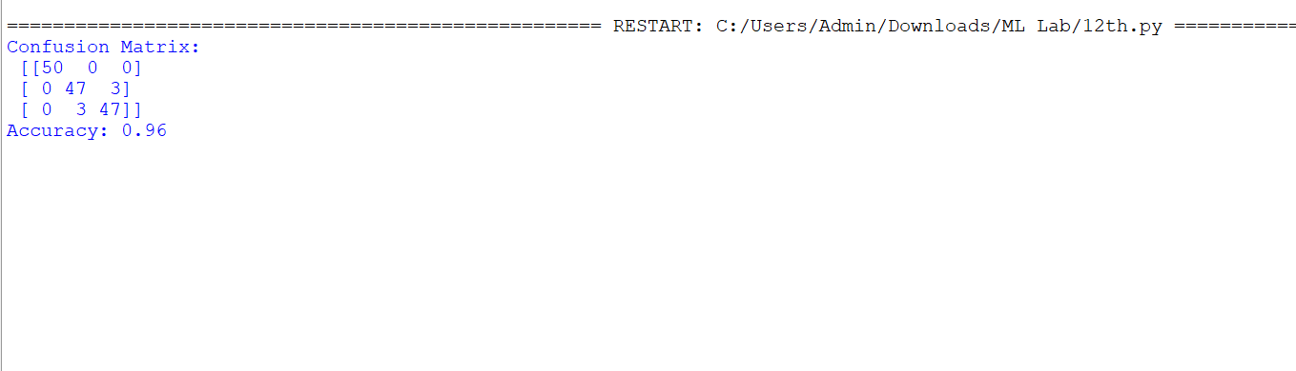

Result
The Iris Flower Classification using KNN algorithm was successfully implemented in Python, and the model performance was evaluated using the confusion matrix and accuracy score.

